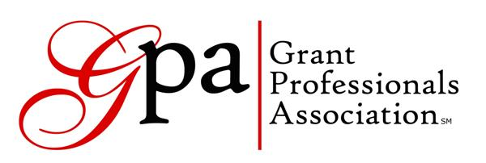
Oregon and SW Washington Chapter Meeting
May 24, 2017

Oregon Food Bank (Eastside Location)
Portland, OR

MEETING MINUTES

Present: Maggie Bonjean (Social Chair), Dale Braden, Sue Jetter, Jennifer Mangieri (President), Lorrie McCullough, Michael V. Paul, Melissa Poulin, Melinda Stoops, Abigail Singer, Karen Warr (Treasurer), Terri Wiley (Secretary), Dana Woods. By Phone: Arthur Davis, Rick Horton, Susy Lacer, Katrina Vinograd.
Officers Absent: Heather Ellis (Vice President), Darcie Spar (Program Chair)

The meeting was called to order at 11:35 a.m. by Jennifer Mangieri.

Chapter Business
Officer’s reports were printed with the agenda.

The chapter recognized two of our chapter members on recently receiving their Grant Professionals Certification (GPC). Congratulations to Dale Braden and Arthur Davis on this achievement!

Jennifer announced the recipients of scholarships for membership and GPA national conference. Congratulations to Andrea Myhre (one-year membership and GPA conference) and Rick Horton (GPA Conference). Additionally, Melinda Stoops was awarded a one-year membership through the national GPA scholarship program.

Our chapter will now be leading the Grants SIG (Special Interest Group) in partnership with WVDO, which has changed its name to Grant Affinity Group. These programs will be offered quarterly, thus in total our chapter will be offering 8 program meetings a year. Darcie Spar (Program Committee) will be leading these efforts. This is a great strategic opportunity for our chapter in terms of strengthening our partnership with WVDO and recruitment of new members.

Upcoming program meetings have been identified: Prioritizing Deciding Which Grants to Pursue (8/23) and Recap of the National GPA Conference (12/6). Future topic ideas include: prospect reach, foundation relations, grants training for your non-grants staff, stewardship discussion, field trips, funder panels. Do you want to help with planning any of these great programs? We are recruiting a work group to help with planning! Contact Darcie Spar, Program Chair, dspar@oregonfoodbank.org.

2018 Regional Conference: Arthur is looking for members to also join a planning group for next year’s conference and help with securing a location. He is exploring PCC as an option, but there are timeline concerns. We need a space with one large room (150 people capacity with tables) and 3-4 smaller rooms for breakout sessions (30-40 people capacity). Please contact Arthur@arthurdavisconsulting.com if you can join the planning group or have a lead on spaces.

The OPEN (Oregon Program Evaluators Network) is having their conference on October 4. This can be a great resource for grant professionals around the area of program evaluation and logic models. Contact Chari Smith for details: chari@smithconsulting.com

National GPA Business:
The national GPA conference will be held November 8-11 in San Diego. The word from online chatter in the GrantZone forums is that the reserved conference lodging is filling up, so it is recommended to book your accommodations soon if you plan to attend. If you wish to find a roommate to share expenses, you can reach out to Barb Boggs with GPA or post to GrantZone.

Shelly Wales is our new chapter relations contact and has been sending resources to chapter officers.
GPA is recruiting for a GPA Region 1 Representative. This is an unpaid position. Details on the GPA website.

The business meeting adjourned at 12:45.

Program: GPC: What It Is, and Why to Get It (or Not)
(see the GPA website to download the Powerpoint presentation)

Next chapter meeting: Wednesday August 23, 2017 at OMSI

