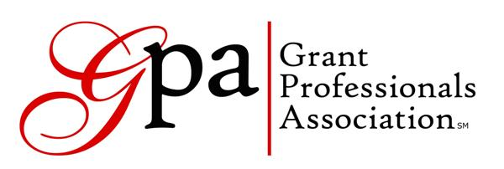
Oregon and SW Washington Chapter
Summer Meeting, August 26, 2015

OMSI
1945 SE Water Ave
Portland, OR

MEETING MINUTES

Present: Melody Ayers, Maryn Boess, Dale Braden, Kim Christenson, Arthur Davis, Heather Ellis, Katie Frederick, Rick Horton, Kari Lawrence, Lorrie McCullough, Jennifer Mangieri, Darcie Spar, Terri Wiley, Karen Warr. By Phone: Alyssa Hanada, Sue Jetter.

VP/Membership Report – Heather Ellis
We now have 41 members, an all-time high, up from 37 in May. We are instituting a new renewal program. Jennifer Mangieri will email, and Rick Horton will call, all those whose memberships will soon or have recently expired. Heather Ellis is also setting up a Google Group for the chapter so that people will have a forum to communicate easily with each other outside of the quarterly meetings.

Treasurer’s Report – Arthur Davis
Balance as of 8/25/2015 is $1,670.67. One year ago, the balance was $1,733.59. The difference is mainly due to timing – this year we paid $275 for a conference scholarship and $250 to the Chuck Howard Scholarship Fund in July and August. Last year these payments occurred in October. Calendar year-to-date income is $570, versus $535 last year. Chapter income comes primarily from membership dues.

President’s Report – Jennifer Mangieri:
Jennifer announced that Virginia Garcia Memorial Foundation and OMSI currently have grant positions open.

A membership survey was distributed to members and friends on our email list and 22 people responded, 70% of whom were members. Responses to the question regarding meeting location were evenly divided between keeping the meetings in one location and rotating them around the area. For now we will rotate and will continue to offer a call-in option. Respondents were interested in additional gatherings so we will be instituting a monthly happy hour gathering, starting in September. Respondents also indicated an interest in mentor/mentee opportunities, so we will be adding a form to the website where people can indicate their interest and particular areas of expertise. A prize drawing was held for the survey respondents, and Maryn Boess won the Starbucks gift card.

Other Business
Rick Horton is teaching grant writing courses at PCC.

Sue Jetter and Maryn Boess are both running for the GPA Board of Directors this year – members, please vote! Voting outside of the conference closes on September 11 at 5:00 p.m. Central time.

This year’s National Conference will be held November 11 – 14 in St. Louis. Maryn Boess and Arthur Davis are both presenting workshops.

PROGRAM

Defining Your Success as a Grant Professional
Darcie Spar led a group discussion on different metrics that can be used when evaluating grant success.

Next meeting: December 2, 11:30 – 1:30, at Oregon Food Bank in Beaverton. The meeting topic will be highlights from the National Conference.

